Mujtaba Muhammad

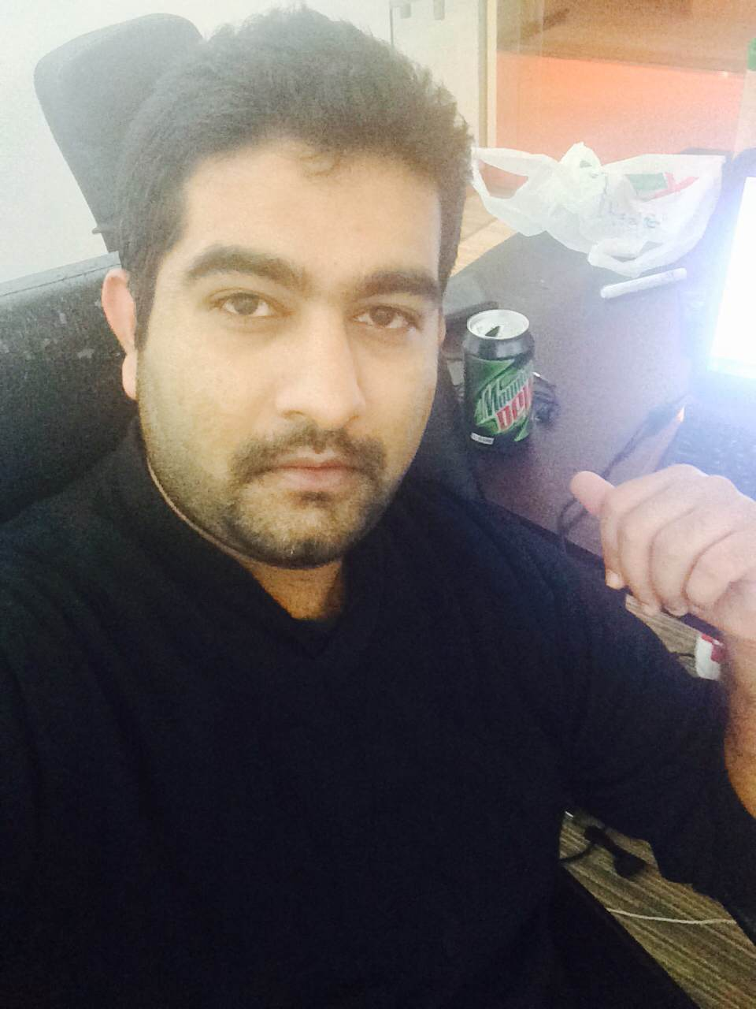

Office 229,Block 4, Gold n Diamond Park, Dubai

+971-52-8276552

[**m.mujtaba99@yahoo.com**](mailto:m.mujtaba99@yahoo.com)

# AREAS OF EXPERTISE

# Software/Web Application Development

* Relational Database Management System
* IT Operations and Support

# CAREER OBJECTIVE

With 6 years of experience in Software Engineering the objective is to take a challenging and high performance oriented role and implement the expertise gained through years to develop business solutions and to acquire more knowledge and learn new technologies and techniques and grow along with the organization.

# SUMMARY OF COMPETENCY

* Hands on experience developing web applications using technologies like **C#.NET, ASP.NET,MVC5, ADO.NET, LINQ, AJAX, JSON, XML, Web Services (SOAP), WCF.**
* Experience as a Lead and mentor for medium size team of developers.
* Extensive experience in **MVC5** framework.
* Strong concepts of Object Oriented programming.
* Ability to identify risks and dependencies and plan product maintanenece and enhancements.
* Provide prototypes/proof of concepts to the business owners and users as a part of requirements process.
* Extensive experience in client side programming like **jQuery, Html5 and Java script**.
* Experience in working as a part of agile development team based on Scrum SDLC.
* Proficient in Reporting tools like Crystal Reports, some experience with SSRS.
* Experience of **SharePoint** **converting/ integration of ASP.Net applications into SharePoint**.
* Experience of working on **E-commerce projects** using **PayFort as payment gateway**.
* Experience of working with other third party Microsoft frameworks like **Telerik Rad Controls and Telerik ORM**.
* Expertise in back end using SQL-Server 2008/ 2012 and RDBMS.
* Good relational database concepts and strong knowledge in SQL/T-SQL/PLSQL
* Ability to work within a team as well as independently with good problem solving ability.
* Excellent Communication skill to present points precisely and clearly.

# EXPERIENCE

I am an astute Software Professional with 6 years of experience I got the opportunity to work on medium to large scope projects by adhering to agile scrum development model. I have the ability to handle multiple projects in parallel, managing small team and solving complex business scenarios. Overall I am a person with good organizational skills.

**Madreqat FZLLC, Dubaï, UAE**

Sr. Software Engineer – Team Lead

Jan 2014 – April 2015

Madreqat is a child company of Senat Group; it provides a variety of web based business solutions to local business which includes Real Estate, E-Commerce, Financial Accounting. As Software lead my responsibilities are to work closely with marketing and sales team, provide prototypes/proof of concepts to the business owners and users as per requiremments, Mentor developers, performing code reviews and manage project commitments, proactively identify and resolve customer issues and delivering quality product on time.

**Netaq Web Solutions LLC, Abu Dhabi, UAE**

Software Engineer

Jan 2013 – Dec 2013

Netaq provides web and mobile based software solutions for both B2B and B2C business models targeting small and large business. Currently I am working as a Software Engineer-ASP.Net/MVC3 developer. As a Software Engineer my responsibility was to work closely with my team lead, gathering requirements based on functional and system requirements. Creating UML models which include high level use cases, sequence dig's, business workflows, creating database and normalization (if required), developing mock ups and actual application based on approved mock ups. Work closely with QA team in testing process through unit, system and user acceptance testing.

**Ovex Technologies (Pvt) Ltd, Pakistan**

Software Engineer

July 2009 – Dec 2012

I got the opportunity to work on a variety of business solutions like E-Commerce solutions and CRM systems based on client’s requirements. My job responsibilities were to gather and identify business requirements, design databases, prepare UML design and mockups, actual implementation of application and to participate in testing process through unit, system and user acceptance tests, frequent meetings with clients and presentations to higher management throughout the project phases.

# PROJECTS

***Tawlat (http://tawlat.com/)***

Tawlat is the biggest loyalty programme in UAE. It covers almost all the top restrurants in UAE. The basic idea of this portal is to provide users with all the possible venues based on their convinicence and choice. Users can register to this poratal and can book a confirmed table at the restrurant of their choice, based on the reservation they are given reward points and later on they can redeem those points at any restrurant of their choice. It’s a complete content management system. Admin user can manage the content. For better understanding please visit the tawlat link.

***Uptown Real Estate CMS (Madreqat RealEstate)***

Uptown web based content management system has been designed to facilitate all the stakeholders; it works as bridge between real estate agencies, agents and the clients. It’s a multi role based system where agency has the admin rights to approve all the properties and contracts made between agents and clients or agent to agent. All the legal documentation with in departments and for ministries has been automated. The system has been developed using Telerik ASP.Net Rad toolkit and Telerik ORM.

***Smile n See CMS (http://smilensee.com/)***

Smile n See is an online store for sunglasses, optical frames n contact lenses. Customers can choose and buy glasses based on their personal style, face shape and budget. It has complete cart n payment gateway funtionality implemented using PayFort payment gateway. There is also an algorithm which suggests sunglasses or frames based on your personal preferences.

***Charlotte Pastries CMS (http://charlotte-pastries.com/)***

Charlotte Pastries is a dubai based french pastries n cakes brand. Customers can choose from variety of pastries and cakes and order online. It has a complete shopping cart with payment gateway integrated with it. Users can register and can place orders. It also has a admin panel from where admin can manage their content and can also add or delete their products.

***R and Z Property Management System***

RandZ property management system is a comprehensive and flexible role based web based application use to cover some basic objectives such as apartment management, room management, tenant management, rent collection. Admin can add property to the system and can assign rooms to teanants, system also helps to keep ladder account of all the tenants for rent collection.

***FissionLink (Netaq Project)***

FissionLink is a Social Media Marketing tool. FissionLink concept is based on marketing through social media like Facebook, twitter, LinkedIn, Google plus. We use social media like facebook, twitter to promote businesses depending upon the target market. People get registered using their facebook account and they are rewarded with gifts and points by a random selection process. It helps any kind of business to promote through concept of reward points and customer loyalty.

***Transport Management System (ADNOC-GASCO Project)***

It’s a comprehensive Vehicle and Transport Management system. This project covers maintenance of vehicles, registration of vehicles for rent, their tracking through tracking devices with real time data monitoring, integration with Oracle financials to deduct fines and other payment directly from employee’s salaries based on data received from Salik. There is a complete Reporting module and customized dashboards as well.

***E-Commerce Solution for BCF Media Chase (Burlington Code Factory Project)***

It is a complete e-commerce solution for online sales and purchase and shipment. This solution is designed and based on Google Feed methodology and covers all the aspects of on line sales/purchase and shipment processes. I got the opportunity to work on Sale, Purchase shipment module specifically zero shipment implementation.

***Project Task Management System (Ovex tech Project)***

System helps clients to create new project requirements or changes in existing system, it helps clients and

project managers to keep track of all the projects assigned to them and to bridge communication gap among

client-manager and manager-employee. Project manager can assign tasks to employees and manage them

System also helps to do effective project cost and time estimations.

***Machine Parts Distribution System-PDX (Komatsu Pakistan Ltd Project)***

I worked on Sales/Purchase and Shipment module of Machine Parts Distribution System. Implemented core

business functionality like Pre-order, Back-order, stock management module among warehouses across

Middle East functionality. Also worked on multilingual versions of system in Japanese, Arabic and Thai

**EDUCATION**

NATIONAL UNIVERSITY OF COMPUTER AND EMERGING SCIENCES, ISLAMABAD May 2005 – May 2009

Bachelor’s degree in Computer Science, Batch 2005

**SKILLS/TECHNOLOGIES**

Proficient in software development technologies such as ASP.NET, C#, MVC5,LINQ, WCF, HTML5, Telerik Rad Controls, Entity Framework, Telerik ORM , jQuery, JSON, AJAX, javascript, XML, business workflows, UML modeling, RDBMS, SQL Server 2012, Crystal Reports.

# REFERENCES

# LinkedIn Profile <http://www.linkedin.com/pub/muhammad-mujtaba/2b/23b/367>

Mr. Mubashar Hassan

Software Manager, Madreqat FZLLC

+971508656238

Other references will be provided upon request.